**POLITICAL JUGGERNAUTS**

**1. Introduction:**

The Lok Sabha is composed of representatives of people chosen by direct election on the basis of Universal Adult Suffrage. The Constitution of India allows for a maximum of 550 members in the House, with 530 members representing the States and 20 representing the Union Territories. The 17th Lok Sabha was formed by the members elected in the 2019 Indian general election. Elections, all across India, were conducted in seven phases from 11 April 2019 to 19 May 2019 by the Election Commission of India.

The Bharatiya Janata Party received 37.36% of the vote, the highest vote share by a political party since the 1989 general election, and won 303 seats, further increasing its substantial majority. In addition, the BJP-led National Democratic Alliance (NDA) won 353 seats.

**1.1Overview:**

The Requirement is to analyze the winners and total voters and electors and Postal Votes of Lok Sabha, and criminal Cases in Each State & Party.  In which State there are more winners and which party got more seats and liabilities and assets of each state. For this Created KPI’s and interactive Visualizations and Dashboard and story Board to bring clean and deep understanding of the data. Analyzing the Lok Sabha election of 2019 can provide valuable insights into various aspects of the election process and political landscape in India.

Problem Understanding, also known as Problem Definition or Problem Identification, is the initial and critical phase of any data analysis or problem-solving process. It involves gaining a clear and comprehensive understanding of the problem at hand, its context, scope, and objectives.

**1.1Purpose:**

Social Impact: It brings Clarity to know what are the weak places and which type of vote’s supports which party and which Category votes support which Party.Business Model/Impact: By conducting an analysis the Party can identify areas for improvement and take steps to enhance the Votes, and increase voter satisfaction and loyalty. Improve its Party reputation,

Which can lead to increased Voter loyalty?

A dashboard is a graphical user interface (GUI) that displays information and data in an organized, easy-to-read format. Dashboards are often used to provide real-time monitoring and analysis of data, and are typically designed for a specific purpose or use case. Dashboards can be used in a variety of settings, such as business, finance, manufacturing, healthcare, and many other industries. They can be used to track key performance indicators (KPIs), monitor performance metrics, and display data in the form of charts, graphs, and tables.

**2. Problem Statement & Design thinking :**

Problem Understanding, also known as Problem Definition or Problem Identification, is the initial and critical phase of any data analysis or problem-solving process. It involves gaining a clear and comprehensive understanding of the problem at hand, its context, scope, and objectives.

  Data preparation, also known as data preprocessing, is a crucial step in the data analysis process. It involves transforming raw data into a clean, structured, and suitable format for analysis. Proper data preparation ensures that the data is accurate, consistent, and ready to be used effectively to derive meaningful insights.

**2.1 Empathy map:**

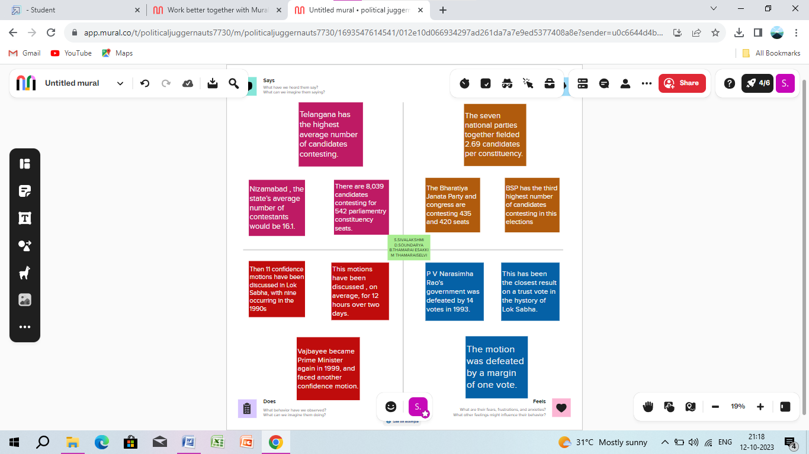

**2.2 Brainstorming Map :**

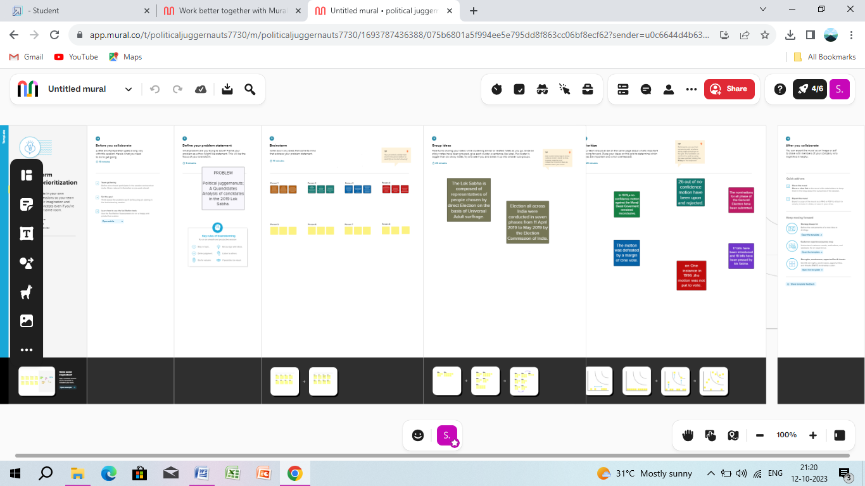

**3. Result :**

Publishing Tableau Desktop to Tableau Public is a process that allows sharing your Tableau visualizations publicly on the internet. Tableau Public is a free cloud-based platform provided by Tableau Software specifically designed for sharing interactive data visualizations with the world. When you publish to Tableau Public, your visualizations become accessible to anyone on the web, and you can embed them in websites, blogs, and social media.

Publishing Tableau Desktop to Tableau Public is a process that allows sharing your Tableau visualizations publicly on the internet. Tableau Public is a free cloud-based platform provided by Tableau Software specifically designed for sharing interactive data visualizations with the world. When you publish to Tableau Public, your visualizations become accessible to anyone on the web, and you can embed them in websites, blogs, and social media.

**4. Advantages & Disadvantages :**

A data story is a way of presenting data and analysis in a narrative format, with the goal of making the information more engaging and easier to understand. A data story typically includes a clear introduction that sets the stage and explains the context for the data, a body that presents the data and analysis in a logical and systematic way, and a conclusion that summarizes the key findings and highlights their implications. Data stories can be told using a variety of mediums, such as reports, presentations, interactive visualizations, and video.

Preparing the data for visualization involves cleaning the data to remove irrelevant or missing data, transforming the data into a format that can be easily visualized, exploring the data to identify patterns and trends, filtering the data to focus on specific subsets of data, preparing the data for visualization software, and ensuring the data is accurate and complete. This process helps to make the data easily understandable and ready for creating visualizations to gain insights into our analysis.

**5.Applications :**

A dashboard is a graphical user interface (GUI) that displays information and data in an organized, easy-to-read format. Dashboards are often used to provide real-time monitoring and analysis of data, and are typically designed for a specific purpose or use case. Dashboards can be used in a variety of settings, such as business, finance, manufacturing, healthcare, and many other industries. They can be used to track key performance indicators (KPIs), monitor performance metrics, and display data in the form of charts, graphs, and tables.

A data story is a way of presenting data and analysis in a narrative format, with the goal of making the information more engaging and easier to understand. A data story typically includes a clear introduction that sets the stage and explains the context for the data, a body that presents the data and analysis in a logical and systematic way, and a conclusion that summarizes the key findings and highlights their implications. Data stories can be told using a variety of mediums, such as reports, presentations, interactive visualizations, and videos.

**6.Conclusion :**

Publishing Tableau Desktop to Tableau Public is a process that allows sharing your Tableau visualizations publicly on the internet. Tableau Public is a free cloud-based platform provided by Tableau Software specifically designed for sharing interactive data visualizations with the world. When you publish to Tableau Public, your visualizations become accessible to anyone on the web, and you can embed them in websites, blogs, and social media.

In Tableau, filters are a crucial feature that allows you to focus on specific data within your visualization or analysis. They enable you to dynamically control what data is displayed based on certain conditions or criteria. Tableau offers various types of filters to refine and manipulate your data, providing you with more flexibility in your visualizations.